

软件项目管理课程报告



课程题目： 智能校园小助手设计与实现

姓 名： 张红伟 学号： 202230310224

姓 名： 陈心毅 学号： 202230310223

姓 名： 唐亚琴 学号： 202230310227

姓 名： 陈美含 学号： 202230310233

学 院：信息工程学院

指导教师： 刘晋

完成时间： 2023 年 5 月

**Contents**

**Contents**

1. Needs analysis 3

1.1 Project Background 3

1.2 Project Objectives 3

1.3 Project Users 3

1.4 Requirements 3

1.4.1 Functional Requirements 4

1.4.2 Project scope 4

1.4.3 Project risks 4

2. Project Plan 4

2.1 Project master plan 4

2.2 Project division plan 6

2.3 Project organization structure 6

2.4 Project risk points 6

2.4.1 Project risk analysis 6

2.4.2 Key points of project implementation 7

2.4.3 Project management Specifications 8

2.5 Milestone Plan and its tracking sheet 10

3. System functions 12

3.1 Introduction of Features: 12

3.2 Target Users: 13

3.3 Operating Instructions: 13

4. Project quality risk 13

4.1 Project risk identification 13

4.2 Quality risk assessment 14

4.3 Assessment of the degree of risk impact: 4.3 Assessment of the degree of Risk impact: 14

4.4 Risk assessment results 15

5. Testplan&Testcase 16

5.1 In general 16

5.1.1 Project background 16

5.1.2 Test purpose 16

5.1.3 Scope of testing 16

5.2. Testing Progress 16

5.2.3 Testing process 17

5.2.2 Test phase division 17

5.2.3 Test implementation process 18

5.2.4 A review of test methods 18

5.3 Test strategy 18

5.3.1 Test function points 18

5.3.2 Testing Methods 19

5.4 Test environment 19

5.4.1 Hardware Test Environment 19

5.4.2 Software Test Environment 19

5.5 Testing Tools 20

5.6 Schedule 20

5.7 Risk analysis 21

5.8 Test cases 22

5.8.1 Test case design 22

5.8.2 Specific test cases 23

5.8.3 Test Script 25

# 1. Requirements analysis

## 1.1 Project Background

In campus life, problems such as waiting in the cafeteria, occupying seats in the library, and not having a free place in the basketball court often bother us and affect our time arrangement. By obtaining the number of people in these venues in real time, we can arrange our time plan more rationally.

## 1.2 Project Objectives

This project is currently in the initial development and research stage, and the main research contents are as follows:

1. Identify the flow of people in canteen, basketball court and badminton hall through image recognition technology

2. Analyze the queuing time and the number of people in the venue according to the flow of people

3. Push data to users by asking questions about the queuing time, etc., and recommend when to eat and the use of the venue

## 1.3 Project Users

Students and faculty

## 1.4 Requirements Description

It is necessary to complete the wechat mini program interface, which can query the number of students in some places of the school in real time;

Upload tree ferns obtained by cameras placed in each place;

The image data is processed in the background to identify the number of people in the image;

And recommend suitable venues to go to based on the number of people in the venues.

### 1.4.1 Functional requirements

1. Functions related to small programs: small programs need to locate functions, select schools and check the number of people in each venue.

2, the number of people detection related functions: in the need to query the number of venues set up cameras, upload picture data at certain intervals, according to the current picture data detection of the number of people in the venues.

3, recommendation related functions: according to the number of venues and other information, through the recommendation algorithm to recommend suitable venues.

### 1.4.2 Project scope

1. Image number recognition

2, number analysis, venue analysis

3. Recommendation algorithm

### 1.4.3 Project risk

During the implementation of the project, the risks may come from the following aspects:

**1. Requirement risk:** there may be changes in business requirements during the development process. In principle, the project plan should be implemented. If there are major changes, report to the teacher, propose a reasonable plan and make the changes.

**2. Technical risk:** In the current scheme, there is no need to care about the user's usage. During the implementation of the project, team members may encounter various technical difficulties.

**3. Risk of plan preparation: the** plan is not perfect, and the ability gap of team members is large.

1. **Process risk: the** ability difference is large, the quality is not good; Failure to complete iteration on time;
2. **Time risk:** during the implementation of the project, if the tasks of team members are not completed, the completion of the whole project will be affected.

# Project planning

## 2.1 Project master plan

|  |  |  |  |  |
| --- | --- | --- | --- | --- |
| Research phase | Start and end times | Research content | Stage objectives | Responsible person |
| 1. Preliminary research and demand analysis stage | 2023.3.5-2023.3.12 | Determine the problem solved by the project, conduct feasibility analysis and demand analysis | Feasibility analysis, demand analysis | Zhang Hongwei |
| 2. Project design phase | 2023.3.13-2023.3.29 | Design the project plan and write the project plan specification according to the demand analysis | Project plan | Zhang Hongwei |
| 3. Software coding stage | 2023.3.30-2023.5.24 | Software coding, development, and the realization of key functions for the technical breakthrough | Software function implementation, two iterations, project plan update | Chen Xinyi, Chen Meihan |
| 4. Functional test phase | 2023.4.27-2023.5.24 | Perform unit, functional tests | Functional test report | Tang Yachen |
| 5 Apply the implementation phase | 2023.4.27-2023.5.24 | Software trial run and demonstration | Operational reports | Tang Yachen |
| 6. Report, closing, acceptance stage | 2023.5.25-2023.5.30 | Complete the preparation of the technical research report, improve the documentation, and prepare the project closure | Revised version of technical research report, application report, project acceptance report | Zhang Hongwei |

## 2.2 Project division plan

|  |  |  |  |
| --- | --- | --- | --- |
| **Task name** | **Start and end times** | **Content** | **Requirements** |
| Front-end learning | 2023.3.23-2023.4.6 | Learn to make GUI design and make for wechat mini program | Complete a simple wechat mini program GUI interface |
| Algorithm learning | 2023.3.23-2023.4.6 | 2 Research and learn feasible number detection schemes that can be applied to images | Give a definite number of people detection algorithm scheme |
| Small program development learning | 2023.3.23-2023.4.6 | 2 Learn the skills related to developing wechat mini programs | Complete a simple demo or give study notes |
| Front-end development | 2023.4.6-2023.4.27 | Develop the applet GUI interface | Complete the first version |
| Algorithm design | 2023.4.6-2023.4.27 | Design of algorithms that can be used for number detection | Complete the first version |
| Small program development | 2023.4.6-2023.4.27 | Wechat mini program development | Complete the first version |
| Testing | 2023.4.27-2023.5.4 | Test the first edition item | Summarize the problem and determine the iteration plan |
| Front-end development | 2023.5.4-2023.5.25 | Improved applet GUI interface | Complete Version 2 |
| Algorithm design | 2023.5.4-2023.5.25 | Improved algorithm | Complete 2nd Edition |
| Small program development | 2023.5.4-2023.5.25 | Wechat mini program development | Complete the second version |
| Closing and acceptance | 2023.5.25-2023.6.1 | Complete the preparation of the technical research report, improve the documentation, and prepare the project closure | Revised version of technical research report, application report, project acceptance report |

## 2.3 Project organization structure

The organizational structure of the project is shown in the figure below:

Group: Software Project Management Group 9

Requirements, Planning, Closing Manager: Hongwei Zhang; Members: Chen Xinyi, Chen Meihan, Tang Yaqin

Development Manager: Xinyi Chen, Meihan Chen; Members: Zhang Hongwei, Tang Yaqin

Testing, Implementation Manager: Tang Yaqin Members: Zhang Hongwei, Chen Meihan, Chen Xinyi

# 2.4 Project risk points

### 2.4.1 Project risk analysis

The life cycle model of this project is shown in the figure below:

|  |  |  |
| --- | --- | --- |
| **Risk** | **Impact** | **Coping measures** |
| **Technical risk:** In the current scheme, there is no need to care about the user's usage. During the implementation of the project, team members may encounter various kinds of risks  Technical difficulties. | Project delays | 1. Make the overall manpower plan and progress plan in advance  2. During the implementation of the plan, constantly evaluate the ratio between the remaining workload and the existing manpower. 3.In case of insufficient manpower estimation, timely feedback and communication are provided |
| **Demand risk:** there may be changes in business requirements during the development process. | Project delays and substandard quality | 1.Do sufficient demand research in the early stage.  2．Execute according to the project plan in principle.  3. The demand report shall be signed and confirmed by key personnel |
| **Time risk:** During the project implementation, if the tasks of team members are not completed, the whole project will be affected | Project delay | 1.Schedule time nodes  2. Complete features on time |
| **Process risk:** time node control is not in place | Project delay, quality is not up to standard | 1.Complete the project according to the time node  2.Ensure the quality of the feature |

### 2.4.2 Key points of project implementation

Determine the timing of key points for project implementation

|  |  |  |
| --- | --- | --- |
| **node** | **Points in time** | **Tasks** |
| Requirements | The 2023-3-20 | Demand research Confirmed |
| Project plan | The 2023-3-29 | Project design Confirmation |
| Development | The 2023-4-27  The 2023-5-24 | 5 Submit a development test version |
| Test group | The 2023-4-27  The 2023-5-24 | Release user test versions |
| System live | The 2023-5-24 | The system is online. |

### 2.4.3 Project Management Specifications

1. Project implementation constraints

1. Key functions should be guaranteed to be completed.
2. All requirements and changes must be confirmed by the teacher

2. Project changes

Make reasonable requirements plan and project plan to reduce the workload of system function adjustment and testing in the iterative process, so as to reduce the risk of project changes.

3. Project communication

1. **Weekly meeting: Every Wednesday evening, the weekly meeting mainly includes:** ① report progress, ② discuss problems, risks and plans
2. **Project report:** Hold project report to teachers and students after the completion of analysis, design and preparation for launch
3. **At the end of the** project: report the use of the system and show the effect.

4. Meeting agenda

1. Needs analysis meeting agenda sheet

|  |  |  |
| --- | --- | --- |
| **Conference name** | **Needs analysis determined** | |
| Purpose of meeting | Determine the needs of the project | |
| Meeting time | 2023.3.5 | |
| Meeting place | Tencent conference | |
| Attendees | Chan Mei Han, Zhang Hongwei, Chen Xinyi, Tang Yaqin | |
| Chair of the meeting | Chan Mei Ham | |
| Timing | Keynote speaker/speaker | Speaking topic |
| 2023.3.5 | Chen Meihan | Analyzing project requirements |
|  | Chen Xinyi, Zhang Hongwei, Tang Yaqin | Discuss the requirements and determine the requirements |
| Remarks: The demand is tentatively determined by image recognition technology, the number of people is analyzed, and the place is recommended | | |

1. Project design meeting agenda table

|  |  |  |
| --- | --- | --- |
| **Name of meeting** | **Project design discussion** | |
| Purpose of the meeting | Determine the software development process | |
| Meeting times | 2023.3.30 | |
| Meeting location | Tencent conference | |
| Attendees | Chan Mei Han, Zhang Hongwei, Chen Xinyi, Tang Yaqin | |
| Presiding over the meeting | Chen Xinyi | |
| Timing | Keynote speaker/speaker | Speaking topic |
| 2023.3.5 | Chen Xinyi | Explaining project functions, mastering and needing to learn techniques |
|  | Mei Han Chen, Hongwei Zhang, Yaqin Tang | Determine your own division of labor and learn techniques |
| Remarks: Learn relevant skills and execute projects | | |

1. Software development meeting agenda

|  |  |  |
| --- | --- | --- |
| **Meeting Name** | **Software development process** | |
| Purpose of the meeting | Determine the needs of the project | |
| Meeting time | 2023.3.5 | |
| Meeting place | Tencent conference | |
| Attendees | Chan Mei Han, Zhang Hongwei, Chen Xinyi, Tang Yaqin | |
| Chair of the meeting | Chan Mei Ham | |
| Timing | Keynote speaker/speaker | Speaking topic |
| 2023.3.5 | Mae Ham Chan | Analyzing project requirements |
|  | Chen Xinyi, Zhang Hongwei, Tang Yaqin | Discuss the requirements and determine the requirements |
| Remarks: The demand is tentatively determined by image recognition technology, the number of people analyzed, and the recommended place | | |

1. Functional test meeting agenda

|  |  |  |
| --- | --- | --- |
| **Meeting name** | **Function point test** | |
| Purpose of the meeting | Determine the testing purpose of the software | |
| Meeting time | 2023.5.25 | |
| Meeting location | Tencent conference | |
| Attendees | Chan Mei Han, Zhang Hongwei, Chen Xinyi, Tang Yaqin | |
| Chair of the meeting | Tang Yaqin | |
| Timing | Keynote speaker/speaker | Speech topic |
| 2023.3.5 | Tang Yaqin | Analyze function points and test points |
|  | Chen Xinyi, Zhang Hongwei, Chen Meihan | Determine the test |
| Remarks: Test 3-10 cases | | |

## 2.5 Milestone Plan and its tracking sheet

|  |  |  |  |  |  |
| --- | --- | --- | --- | --- | --- |
| Document Number | 001 |  | Check the date | 5.25 |  |
| Project name | Smart Campus Little Assistant | | Project Manager | Group |  |
| Checkpoints or milestones | The milestone leader | Planned completion date | Actual completion date | Whether or not completed | Remarks |
| Front-end learning | Zhang Hongwei | 2023.3.23 - | 2023.3.30 | Finished | Complete a simple wechat mini program GUI interface |
| Algorithm learning | Small group | 2023.3.25 | 2023.4.8 | complete | Complete picture number identification |
| Small program development learning | Group members | 2023.3.28 | 2023.4.6 | Finished | A simple demo has been completed |
| Front-end development | Mei Ham Chan | 2023.4.25 | 2023.4.27 | Finished | Complete the first edition |
| Algorithm design | Mei Ham Chan | 2023.4.6 | 2023.4.10 | Finished | Design of algorithm for number of people detection |
| Small program development | Chen Xinyi | 2023.4.25 | 2023.4.27 | Finished | Complete the first edition |
| Testing | Tangyachen | 2023.4.30 |  | Not completed, final version test |  |
| Front-end optimization | Mei Ham Chan | 2023.5.4 - | 2023.5.25 | Finished | The interface is more aesthetically pleasing and reasonable |
| Algorithm design | Mei Ham Chan | 2023.5.4 - | 2023.5.25 | Finished | Reduced run time |
| Small program development | Chen Xinyi | 2023.5.4 - | 2023.5.29 | Finished | Normal operation |
| Testing | Tangyachen | 2023.4.27 - | 2023.5.30 | Finished | Generate test report |
| Closing, acceptance, and reporting | Zhang Hongwei | 2023.5.25 | 2023.6.1 | To be completed | Test reports, project plans, quality reports, powerpoint, milestones |

# 3. System functions

## 3.1 Introduction of Features:

The Smart Campus Assistant is an innovative tool that aims to make your life on campus more convenient and efficient. By utilizing advanced image analysis techniques, it is able to accurately determine the number of people present in various areas of the campus. This information is crucial for planning your travel, as it allows you to avoid overcrowded areas and choose alternative routes or times to reach your desired destination.

With the real-time image analysis feature, the Smart Campus Assistant provides you with up-to-date data on the crowd density in different locations. Whether you're heading to the library, cafeteria, or a specific classroom, the assistant can analyze the images captured by campus cameras or uploaded by users to assess the level of congestion. By doing so, it ensures that you can make informed decisions about your travel plans, ultimately saving you time and reducing the chances of encountering crowded spaces.

Moreover, the Smart Campus Assistant goes beyond simply providing crowd density information. It also uses intelligent algorithms to recommend suitable travel plans based on the analyzed data. For example, if the analysis indicates that the library is heavily crowded, the assistant might suggest alternative study areas or quieter times to visit. Similarly, if the cafeteria is particularly busy, it can propose alternative dining options or suggest less crowded time slots.

The integration of the Smart Campus Assistant into the popular WeChat platform makes it easily accessible to users. By simply opening the mini-program, you can interact with the assistant, upload images for analysis, and receive personalized travel recommendations within seconds. This seamless integration enhances the user experience, ensuring that you can effortlessly plan your movements on campus and make the most of your time.

## 3.2 Target Users:

Teachers and students on Campus

## 3.3 Operating Instructions:

To use the Smart Campus Assistant, follow these simple steps within the WeChat mini-program:

1.Open the WeChat mini-program for the Smart Campus Assistant.

2.On the main screen, locate the "Select Location" section.

3.Tap on the "Select Location" button to choose the desired destination or place you want to visit within the campus.

Once you have selected the location, the system will begin processing the real-time image of that place. Using advanced image analysis techniques, it will calculate the current number of people present in that location. Additionally, it will also analyze the real-time pedestrian detection results from similar locations.

After the analysis is complete, the system will provide you with the real-time crowd data for the selected location and present you with the pedestrian detection results in the form of an image. This image will help you visualize the current situation at the chosen place.

Based on this information, the Smart Campus Assistant will then recommend the most suitable location for you to visit, taking into consideration the real-time crowd data and the pedestrian detection results. The recommendation will aim to suggest places that are less crowded or offer alternative options if the selected location is heavily crowded.

By following these steps and utilizing the real-time crowd data and pedestrian detection results, the Smart Campus Assistant assists you in making informed decisions about your travel plans within the campus environment. It ensures that you can choose the most suitable and convenient locations to visit, optimizing your time and avoiding overcrowded areas.

# 4. Project quality risk

## 4.1 Project risk identification

We use SWOT analysis for project risk identification.

|  |  |  |  |  |  |
| --- | --- | --- | --- | --- | --- |
|  | Strength | | | Weakness | |
|  | Easy to enter data acquisition | Embedded algorithm blocks | Encapsulated user interface | The user interface is not pleasing | The scenarios are not diverse enough |
| Opportunity | Video data is diversified, and framing efficiency is improved | Easy to change algorithms for different effects | Easy to design and handle user interface modules | The interface can be optimized based on user feedback or member self-testing | As the software becomes more stable, different scenarios and functions can be added |
| Threat | Select or convert to supported data input formats (video, images) whenever possible | Choose the most efficient and stable algorithm possible | Adjust the interface as much as possible to make it user-friendly | It may directly lead to a decline in user experience and affect the market of software | Lack of interactivity and choice |

## 4.2 Quality risk assessment

The quality risks included:

1. The user interface is not user-friendly.

2. The algorithm is not efficient.

3. The recommendation function is not smooth.

4, The test is not comprehensive enough

|  |  |
| --- | --- |
| **Probability level** | **The possibility of happening** |
| 0.9 | Very high |
| 0.7 | high |
| 0.5 | middle |
| 0.3 | low |
| 0.1 | Very low |

## 4.3 Assessment of the degree of risk impact:

|  |  |  |  |  |  |
| --- | --- | --- | --- | --- | --- |
| **Impact degree project objectives** | **Very high**  **0.9** | **High**  **0.7** | **Middle**  **0.5** | **Low**  **0.3** | **Very low**  **0.1** |
| cost | Greater than 20% cost increase | 10%-20% cost increase | 5%-10% cost increase | Less than 5% cost increase | Not obvious cost increase |
| Progress | Overall project delays greater than 20% | Overall project delays 10%-20% | Overall project delays 5%-10% | Overall project delays less than 5% | No noticeable delays |
| quality | The project product has no practical use | The quality drops to the point that it is unacceptable to the user | The decline in quality only affects very strict requirements | quality is  imperceptible | Loss of quality is almost imperceptible |

## 4.4 Risk assessment results

|  |  |  |  |
| --- | --- | --- | --- |
| Risks | Probability | effect | sort |
| The user interface is not user-friendly. | 50% | 3 | 3 |
| The algorithm is not efficient. | 50% | 4 | 1 |
| The recommendation function is not smooth. | 40% | 4 | 2 |
| The test is not comprehensive enough | 30% | 3 | 4 |

# 5. Testplan&Testcase

## 5.1 In general

### 5.1.1 Project background

In campus life, problems such as waiting in the cafeteria, occupying seats in the library, and having no free space in the basketball court often bother us and affect our time arrangement.By obtaining the number of people in these venues in real time, we can arrange our time plan more rationally.

Through the wechat mini program, we can query the real-time number of people in crowded places on campus in real time, and decide the appropriate venues to go to according to the number of people.

### 5.1.2 Test purpose

Smart Campus small assistant wechat mini program is a wechat mini program used to count the number of people in school libraries, playgrounds and canteens on mobile devices.The test aims to evaluate its functionality and robustness to ensure that it can correctly complete pedestrian traffic statistics in a variety of scenarios and provide a user-friendly experience.

### 5.1.3 Scope of testing

This test plan will test the following aspects:

1. Image input function
2. Whether the number of people detected is accurate
3. Algorithm accuracy
4. Robustness
5. Performance

## 5.2. Testing Progress

### Testing process

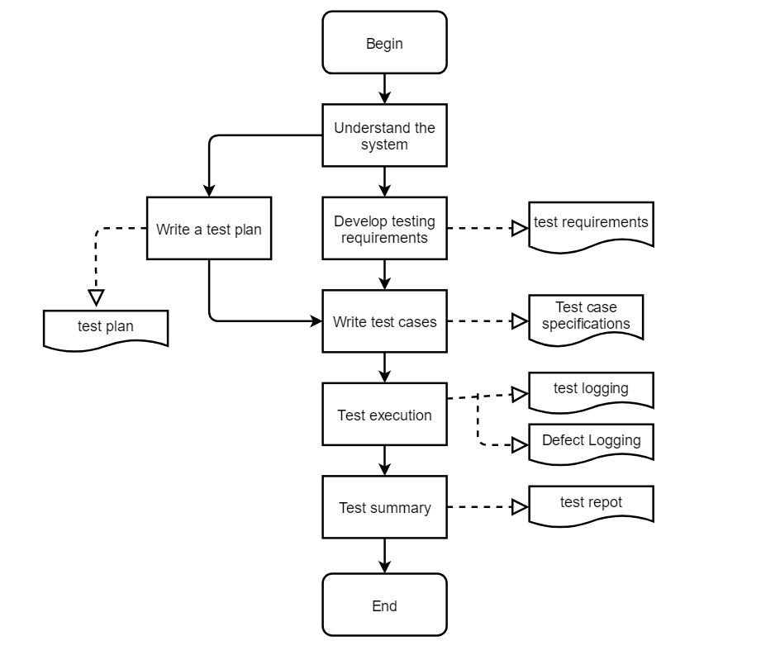

### 5.2.2 Test phase division

In this project, we divided the whole testing process into several testing phases, and only after reaching one testing phase can we transfer to the next phase to control the whole process.

We divided the entire testing process into the following stages:

|  |  |
| --- | --- |
| Testing phase | **Completion Criteria** |
| System training: | 1. Complete training for all systems to be tested in this project 2. The tester has used all the systems/modules under test and understood the specific functions of the system under test |
| Test requirements: | 1. All specific test areas have been identified 2. Test requirements have been developed 3. All test requirements are approved by the customer |
| Test design: | 1. Test cases have covered all test requirements 2. The test case design is complete |
| Test execution: | 1. All test cases are executed 2. Defects found have defect records 3. Test procedures have test records |
| Analysis of results: | 1. Complete the test analysis report |

### Test implementation process

In this project, a tester is responsible for testing different sub-functions. The implementation process is as follows:

1. 4. Prepare the required environment for testing
2. Prepare the data required for the test
3. Execute test cases according to the system operation structure
4. Document the test process and any defects found
5. Reporting defects

### A review of test methods

Tests in this project include:

1. Functional test: test whether there are defects in each function
2. Performance test: Test the performance data of the system under a certain environment
3. When the tester performs the test, it should strictly follow the content of the test case to perform the test work.
4. The tester records the test execution in the test execution log document.
5. The tester records any problems found during the test into the defect record.
6. Test organization

This chapter mainly describes the structure and responsibilities of the test team, the functional division of test participants, and their contact information

## 5.3 Test strategy

### 5.3.1 Test function points

| **Test items** | **Importance** | **Passing criteria** |
| --- | --- | --- |
| Check the number of users | high | Test the accuracy, sensitivity and response speed of the population detection algorithm to ensure that the algorithm can normally detect the number of people information and update the population data in real time. |
| Data storage and processing | high | Test the stability and reliability of data storage and processing to ensure that population data can be stored and processed accurately and that data can be acquired and updated in real time. |
| Smart recommendation | Medium | Test the accuracy of the intelligent recommendation algorithm and the relevancy of the recommendation results to ensure that the recommended products, activities and services are highly attractive to users. |

### 5.3.2 Testing Methods

The test will be conducted using the method of automated testing.The automated test evaluates the user interface and interactive functions of the Smart Campus small Assistant wechat mini program as well as the functions and performance of the smart Campus small assistant wechat mini program.

The automated test will use tools such as Appium.The test cases will be written according to the function points and requirements of the wechat mini program of the Smart Campus small Assistant, and will be run on actual devices.

## 5.4 Test environment

### 5.4.1 Hardware Test Environment

|  |  |
| --- | --- |
| **CPU** | 12th Gen Intel(R) Core(TM) i5-12500H 2.50GHz |
| **Operating System** | Windows 11 |
| **Memory** | 16GB |
| **Hard drive** | 512GB |
| **Video card** | NVIDIA GeForce  RTE 2050 |

### 5.4.2 Software Test Environment

|  |  |
| --- | --- |
| **Software requirements** | **Purpose** |
| Pycharm | Write back-end code that identifies the number of people algorithm |
| Wechat developer tools | Design the front-end wechat mini program interface of intelligent campus small assistant |

## 5.5 Testing Tools

|  |  |
| --- | --- |
| **Testing Tools** | **Uses** |
| Appium | Automatic test of UI for wechat mini program |
| PyCharm | Write test scripts using PyCharm |

## 5.6 Schedule

|  |  |  |  |  |
| --- | --- | --- | --- | --- |
| **Personnel** | **Test tasks** | **Workdays** | **Start time** | **End time** |
| Chen Xinyi, Tang Ah Qin, Zhang Hongwei, Chan Mei Han | 1. Determine test objectives 2. Determine test scope 3. Determine testing resources and schedule | 1 | May 26, 2023 | May 26, 2023 |
| Tang Yachen | Writing a test plan | 1 | May 26, 2023 | May 26, 2023 |
| Chen Xinyi | Review various test documents written by testers | 1 | May 26, 2023 | May 26, 2023 |
| Chen Xinyi, Tang Yaqin, Zhang Hongwei and Chan Mei Han | Identifying test points | 1 | May 26, 2023 | May 26, 2023 |
| Tang Yachen | Design test cases | 1 | May 27, 2023 | 27 May 2023 |
| Tang Yachen | Test environment setup and data preparation | 1 | May 28, 2023 | May 28, 2023 |
| Tang Yachen | Designing test scripts | 1 | May 29, 2023 | 29 May 2023 |
| Tang Yachen | Perform functional and performance tests | 1 | May 30, 2023 | May 30, 2023 |
| Tang Yachen | Writing test reports | 1 | May 30, 2023 | May 30, 2023 |

## 5.7 Risk analysis

|  |  |  |
| --- | --- | --- |
| **Project risk** | **Risk analysis** | **Avoidance methods** |
| **Failed tests** | If the submitted test version is developed and the smoke test is not passed, the test version must be called back and resubmitted, which may cause a delay in the schedule and affect the subsequent test work arrangement. | Development should take the time to test itself before submitting a test version, or schedule for unit and integration tests if they are not being performed.If the due version is called back, in order not to affect the progress of the overall plan, developers need to arrange for additional staff or overtime. |
| **Delays in development schedule** | If the development cannot be completed within the time specified in the plan, it will cause the delay in the arrangement of subsequent test work, thus causing the risk of the execution of the test plan. | Please ask the project manager to strictly control the progress during the project. If there is any risk of delay, please inform the tester immediately and negotiate to solve the problem.If the plan cannot be completed on time, the tester shall apply for modification of the test plan or apply for overtime work and inform the relevant leader. |
| **Difficult-to-fix permissions cause test cases to stall** | If bugs that are difficult to be fixed are found in the test version during the test execution, the function of the tested module will be blocked and the test schedule will be affected. | If such a problem occurs, the developer needs to fully cooperate with the test and modify the problem in time.If not fully fixed, provide the test with an interface to test the blocked module or a way to bypass it. |

## 5.8 Test cases

### 5.8.1 Test case design

The test cases of this test are organized and written by the tester in accordance with the system hierarchy according to the customer's introduction to the system and their own understanding of the system after system training.

The writing of this system case uses the analysis method commonly used in black box testing to design use cases;

1. For each test case, the test designer should specify the input (or operation), the expected output (or result);
2. For each test case, there must be a detailed description of the test steps;
3. All test cases of this test design must be saved in a standardized document;
4. During the whole test process, the test cases can be changed according to the actual situation of the project;
5. The preparation of test data in test cases, under the guidance of customers and business personnel and the assistance of developers.
6. Arrange the execution of use cases according to the operational structure of the system;

### 5.8.2 Specific test cases

|  |  |  |  |  |  |  |  |
| --- | --- | --- | --- | --- | --- | --- | --- |
| **Test case No** | **Function points** | **Preconditions** | **Performing steps** | **Expected results** | **Purpose of the use case** | **Degree of importance** | **Execute use case test results** |
| 1 | Number of people tested | The user goes to the applet page | Enter the playground test image on an overcast day | The number of people included in the test image should be the same as the number returned by the applet | Test the accuracy of the number recognition algorithm | high | pass |
| 2 | Number of people tested | The user goes to the applet page | Enter the playground test image on an night day | The number of people included in the test image should be the same as the number returned by the applet | Test the accuracy of the number recognition algorithm | high | pass |
| 3 | Smart Recommendations | The user goes to the applet page | Click on [recommendations] to view recommendations | Return to the venue with the least foot traffic currently in the recommendation | Test if the applet can recommend places based on foot traffic | Medium | Don't pass |
| 4 | Smart Recommendations | The user goes to the applet page | Click on [recommendations] to view recommendations | Return the venue with the most historical foot traffic in the recommendation | Test whether the applet can recommend people to their favorite places based on historical data | Medium | Don't pass |

### 5.8.3 Test Script

1. Test Case1: Enter the playground test image on an overcast day, The number of people included in the test image should be the same as the number returned by the applet;

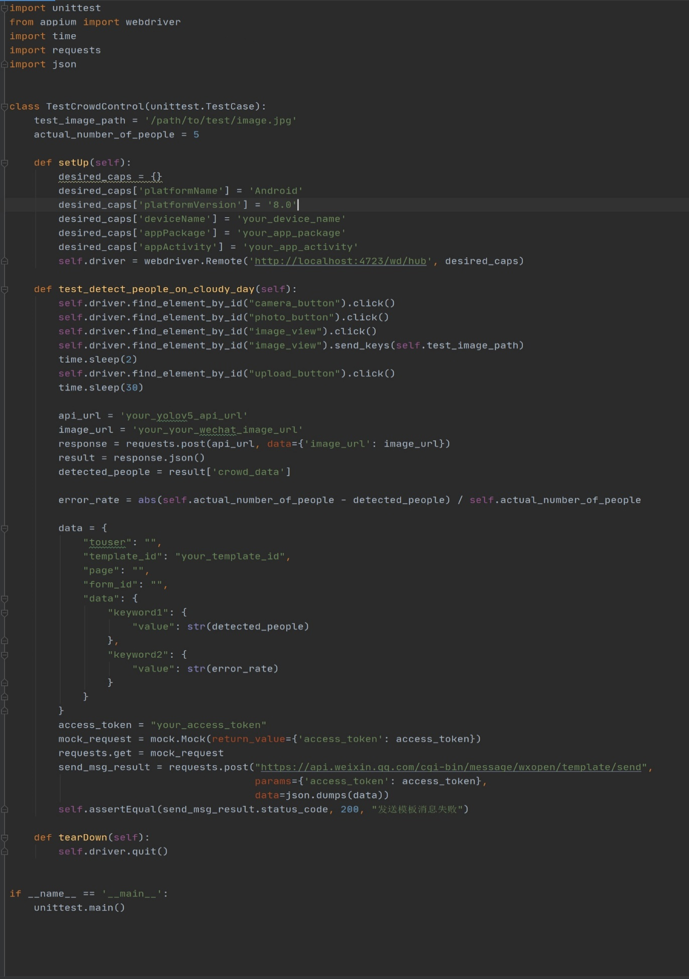

2. Test Case2: Enter the playground test image on an night day, The number of people included in the test image should be the same as the number returned by the applet

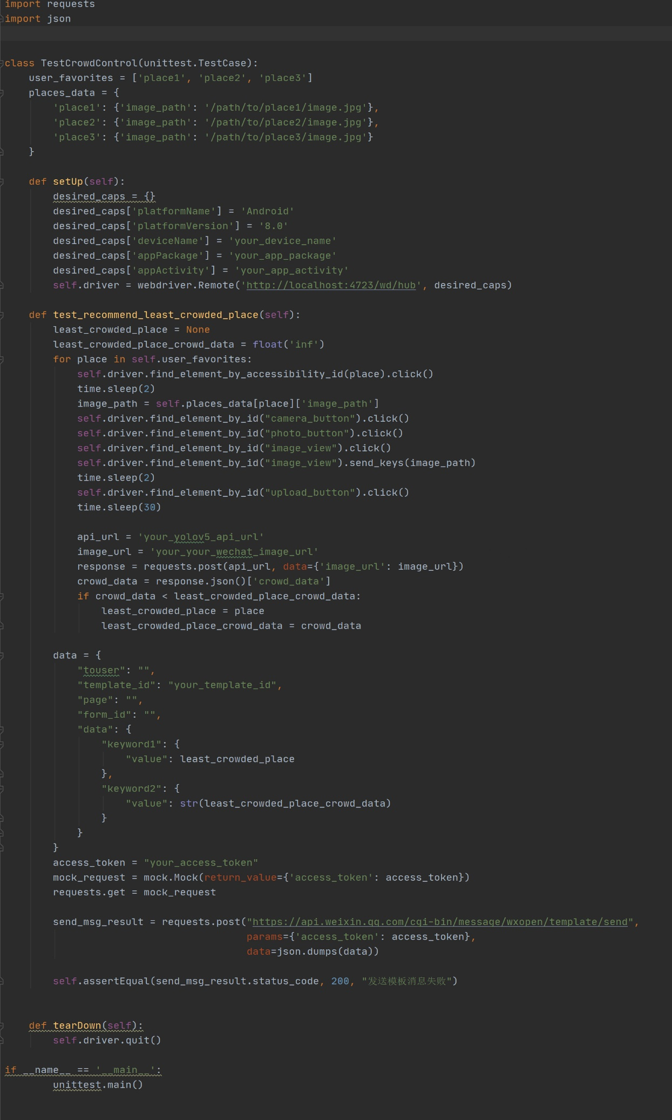

3. Test Case3: Return to the venue with the least foot traffic currently in the recommendation

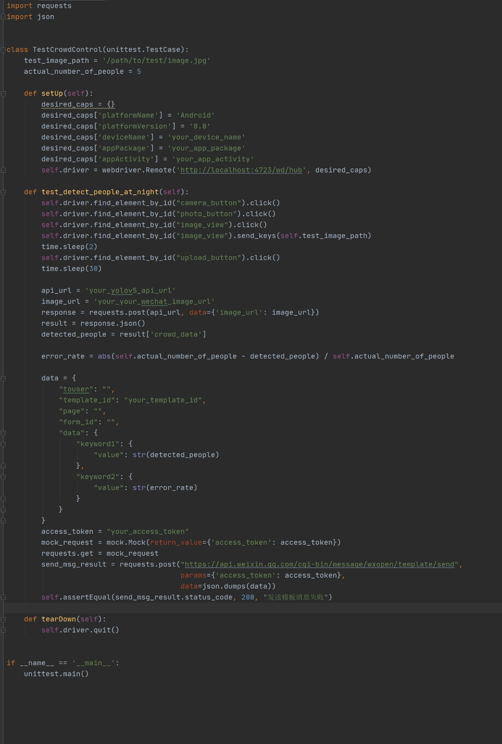

Test Case4: Return the venue with the most historical foot traffic in the recommendation. Test Case4: Return the venue with the most historical foot traffic in the recommendation

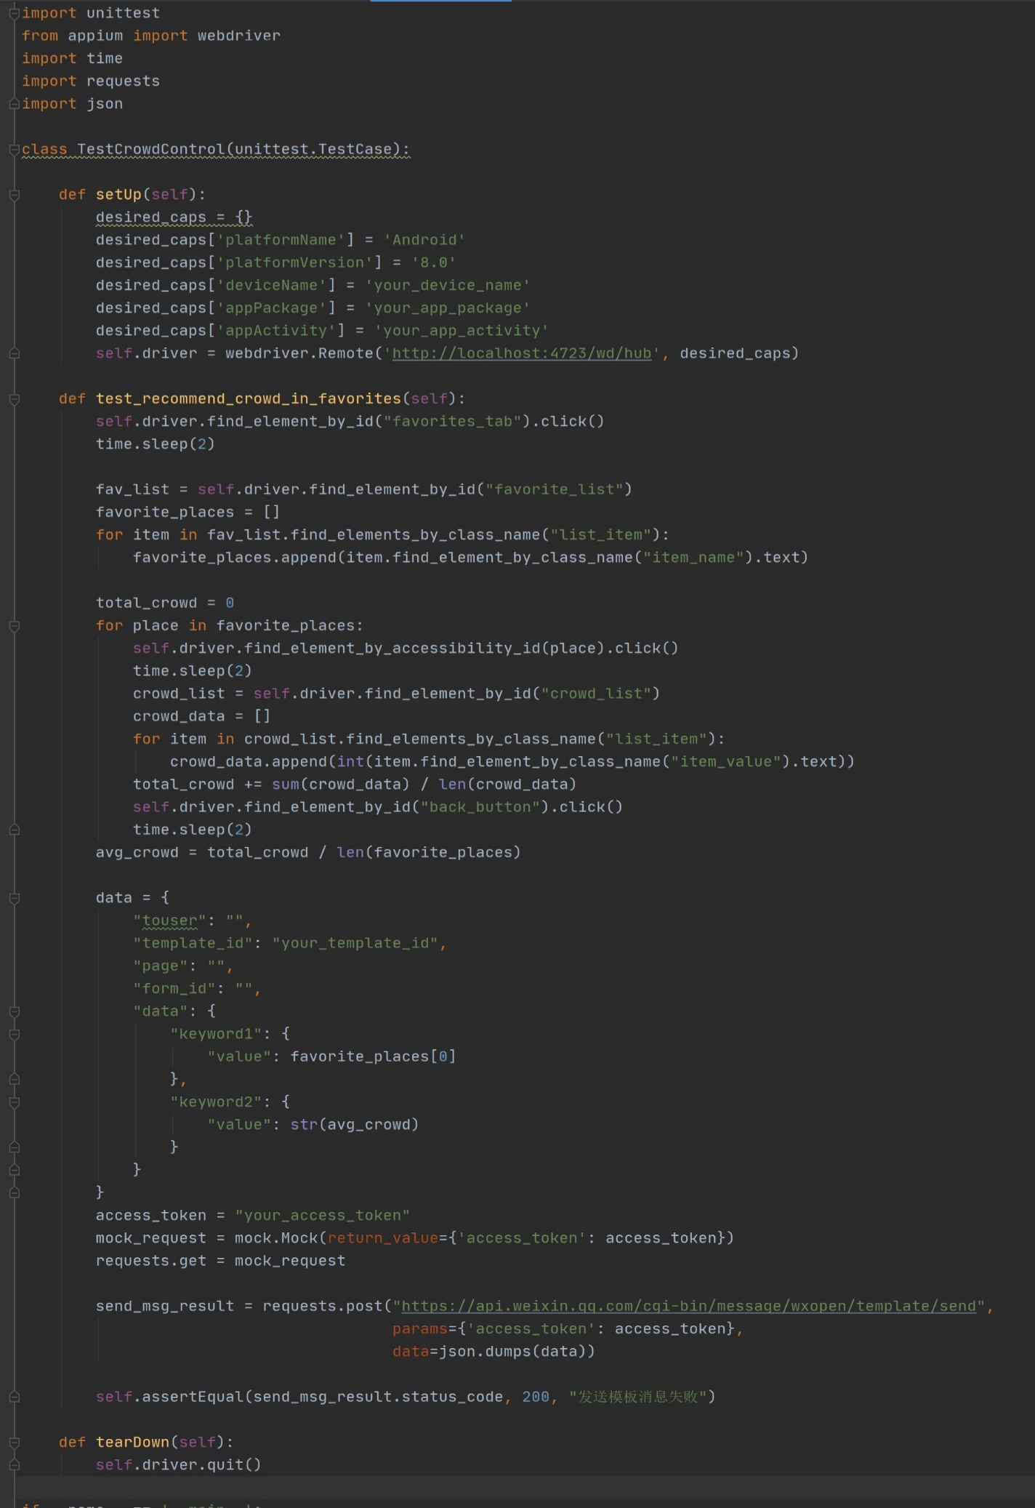

# 6. Lession learn

Time passes so quickly! In the blink of an eye, this course has ended. Overall, this period of time has been busy, fulfilling, and enjoyable. The course mainly taught us management, and we treated the project as a real project to work on. I have benefited a lot and have gained some insights and experiences:

1. Develop reasonable plans: Before starting a project, it is crucial to develop a reasonable project plan that can help the project team better understand the scope, objectives, budget, and timeline of the project.

2. Make timely adjustments to the plan: While plans are essential, project managers and team members must realize that they often need to be modified and adjusted, especially when project risks are identified.

3. Allocate resources reasonably: Resources are limited in software projects, so project managers must allocate them reasonably, including time, budget, personnel, and machines.

4. Manage project risks: Risks are part of software projects, and project teams must understand and manage them. Project managers should develop a risk-management plan, including risk identification, assessment, response strategies, and control.

5. Establish effective communication channels: Good communication is the key to successful software project management. Project managers and team members should establish effective communication channels, which can reduce misunderstandings and improve communication efficiency.

6. Validate and Verify Software Requirements: In the early stages of a project, it is critical to validate and verify whether software requirements are clear, complete, accurate, and understandable.

Overall, software project management is a complex and lengthy process. In project management, problems and challenges will become more comfortable. Therefore, project managers must focus on dealing with challenges positively, rely on and cultivate team members, and enhance their independent thinking and decision-making abilities.

# Conclusion

The goal of the Software Project Management course is to help students master best project management practices in order to achieve project success. In this course we learn about various aspects of project management including project planning, resource management, risk management, cost management, time management, quality management, communication and exchange, project initiation and team management to name a few.

In the early stages of a project, we first learn how to plan and manage a software project. This includes how to understand and define project requirements, develop a project plan, set a project budget, determine the project schedule and timetable, and how to effectively organise project resources to meet project needs. We learn about project management standards, methods, tools and how to prepare a clear project plan and project management plan.

In the mid and late stages of project implementation, we learned how to use various tools and techniques to manage project schedules, risks and costs. We looked at different project risks and learnt how to develop a project risk management plan and project risk assessment. We learned about financial management to control project costs and how to use project metrics and indicators to keep an eye on project progress and quality.

Communication and communication are also very important in software project management. We learnt how to communicate and coordinate effectively with team members and stakeholders during all phases of project management. We also looked at various written and verbal communication tools and techniques in order to ensure that we receive clear feedback and communication from all parties involved in the project.

Project initiation and team management is also an integral part of the Software Project Management course. During the course, we learn how to initiate a software project, including defining the project vision and objectives, organising the project team, and establishing effective communication and leadership styles. In terms of team management, we learn how to motivate, manage and control the project team to ensure the successful implementation of the project.

Finally, through this course, we learnt how to apply what we have learnt in real-life projects. We worked in groups to complete a real-life software development project and addressed the issues and challenges of a real project through the practical application of various aspects of project management. We examined aspects of the project management body of knowledge to ensure the successful implementation and management of the project.

# Future plan for next cycle

In the next round of future developments, we will continue to optimise and develop to provide an even better, more efficient and accurate service.

Firstly, we will continue to work on improving the accuracy and stability of our headcount recognition algorithm. We have successfully implemented headcount recognition using the Yolov5 algorithm for some time now, but as the market becomes more competitive, continuous learning and improvement is key to our continued improvement in accuracy and stability. We will continue to probe deeper into the details of the algorithm, optimise the model and training data, and validate the algorithm in practice through field testing to provide a more accurate and reliable service to our users.

Secondly, we will look at the broader scenario of headcount recognition. Currently, we apply headcount recognition to a small range of scenarios, such as libraries, playgrounds and other environments, while in the future we will expand to more headcount recognition scenarios, such as school buildings, school supermarkets and so on. Through field testing and algorithm optimisation of different scenarios, we will gradually develop a more comprehensive and accurate headcount recognition service to provide users with a more convenient and efficient headcount recognition service.

Thirdly, we will continue to introduce new features. We will consider adding more features to the applet in addition to the headcount recognition service, based on user feedback and demand. For example, we can develop analysis functions based on historical data to provide users with a more comprehensive data analysis service; in addition, we can add functions such as headcount recognition and area monitoring, and colour recognition to meet the needs of different groups of people.

Fourthly, we will continue to optimise the user experience. In order to have a better small program service, we will continue to optimise the interface design, fix known problems and bugs, simplify the user operation process, improve the response and running speed, etc. Through continuous improvement and refinement, we will continue to improve the overall experience of our users.

Finally, we can also adapt the applet to more platforms. In addition to the WeChat applet, we may also develop versions for other platforms (e.g. Android, iOS, Web, etc.), which will allow more users to use our services.

In the future, we will continue our efforts to provide more comprehensive, efficient and reliable number recognition services to our users.